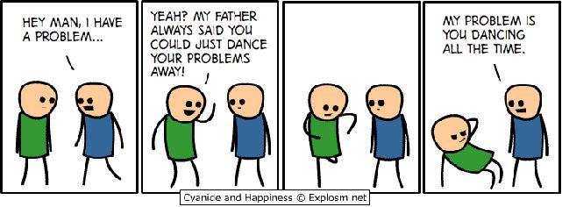

Dance 3/4 Syllabus Sandra Reyna-Urbina

Conference Times: G2 & P3; or by appointment 100A
Class Website: http://www.houstonisd.org/domain/29838

PHILOSOPHY
Dance students develop perceptual thinking and moving abilities in daily life that promote understanding of themselves and others and allow them to interact effectively in the community. By mastering movement principles and skills, students develop self-discipline, and healthy bodies that move expressively, efficiently, and safely through space and time with controlled energy. We will follow the Texas Essential Knowledge and Skills /Student Expectations outline, which includes learning to think, read, write, speak, and listen skillfully in conjunction with using all levels of thinking skills.

OBJECTIVES Chapter 117. Texas Essential Knowledge and Skills for Fine Arts Subchapter C. High School
- Perception: The student will develop an awareness of the body’s movement, using sensory information while dancing.
- Creative expression/performance: The student will apply sciences and fitness principles to dance and will develop knowledge in the choreographic process.
- Historical/cultural heritage: The student will demonstrate and understand the cultural, historical, and artistic diversity.
- Response/evaluation: The student will make informed judgments about dance’s form, meaning, and role in society.

RESOURCES
- Music, library and school approved videos
- Guest choreographers

GRADES

Written Assignments 10%

Final Exam 15%

Quizzes 10%

Tests/Evaluations 15%
Performances 25%
Participation 25%
TOTAL 100 %

PERFORMANCES (TEKS 3A, 3C, 3D, 5B)
Required performances outside of the classroom will be mandatory. You will have at least 2 outside class required performances. The dates will be given at least a month in advance.

SUPPLIES
- Black form-fitting top & bottom; black jazz shoes
- Folder _____________
- Composition Book
- Gmail address

General Rules & Guidelines
- Follow HISD Student Code of Conduct
- Respectful of classmates, teacher and property
- Punctuality
- Positive attitude and ready to learn
- Full participation
- Attend class regularly
- All hair must be away from face in a ponytail or bun.
- All battery operated devices need to be in the phone booth at the beginning of class
- No jewelry
- No consumption of food, carbonated drinks, or gum chewing during class. Water and sports drinks are allowed during break time only.
- No talking during warm-up or instruction.
- Nurse visits will be kept at a minimum.
- If you are not dressed you are still required to participate in any instructional activity. You will only get 60 points for the day, if you do not dress out. You will be required to write why you did not dress out.

TARDY POLICY
- Will follow Jeff Davis Tardy Policy

Restroom Passes
Each student will have 6 passes for the semester. For emergency use only.

Absences
- Absences must be excused in order to make up any missed assignment/test/quiz. *Note that for most group assignments and individual practice there will be a 400-word typed essay due for each absence. Assignment will be due 1 week after excused absence. Make-up work is your responsibility.

TUTORIALS
- Tutorials can be made up by appointment and during the lunch period.

Dear Parent/Guardian,
I am looking forward to having a very successful year with your child! Let’s work hard together, so that your child can have a successful semester. Feel free to schedule a conference with me and I will try to accommodate your schedule. I look forward to seeing you as part of our audience during recital times.

Sincerely,

Ms. Sandra Reyna-Urbina
(713) 226-4900
sreyna@houstonisd.org
mssreyna@gmail.com

Dance 3/4 Syllabus | Ms. Sandra Reyna-Urbina
Student Name: | 100A

Student Agreement

Student please initial the following:

Student Expectations
___ I received the dance syllabus.
___ I gave my parents the dance syllabus for them to read.
___ Follow HISD Student Code of Conduct

___ I will be respectful of my classmates, teacher and property.
___ I will be on time to class.
___ I will have a positive attitude and be ready to learn.
___ I will fully participate in class activities and lessons.
___ I will attend class regularly.
___ I understand that I can consume water or sports drink during break time.
___ I will place my battery operated device in the phone booth.
___ I will not talk during warm-up or instruction.
___ I understand that nurse visits will be kept at a minimum.
___ I understand that if I do not dress out I am still required to participate in any instructional activity and will only 60 points for the day.
___ I understand that I will be required to write out why I did not dress for class.

___ I understand the classroom guidelines stated on the syllabus.

_____________________________ ______________
Parent’s Name (please print) Date

_____________________________ _____________________________
Parent’s Signature Student's Signature

